Momentum — How Your App Works
A simple walkthrough of your fitness tracker, Momentum. This guide explains what the app does and takes you through each part of it, one screen at a time, in plain language. You can read it before your defence so you can talk through every screen with confidence.
What the app is
Momentum is a fitness tracker built for people with disabilities — especially wheelchair users and people with limited mobility. Ordinary fitness apps only count steps, so if you move by wheeling, seated workouts or physiotherapy, they record your effort as nothing. Momentum fixes that. Instead of steps, it tracks rolling distance, active minutes and workout sessions, and the whole app — the exercises, the goals, the encouragement — is built around that kind of movement. It is also built to be easy to use for people with low vision or limited hand movement, with a high-contrast mode, larger text options and big, clearly labelled buttons.
Getting started: the onboarding questions
The first time someone opens Momentum, the app asks a few short setup questions. There is no email or password — it goes straight into these questions, so nothing gets in the way. There are three quick steps:
- Step 1 — Your name. You type the name you would like the app to call you. It uses this for a friendly greeting, like “Welcome back, Emmanuel.”
- Step 2 — Your mobility profile. You pick the option that best describes how you move — manual wheelchair, power wheelchair, limited mobility, or physiotherapy and recovery. This tells the app which activities and exercises to focus on for you.
- Step 3 — Your weekly goals. You set how far you want to roll, how many active minutes and how many sessions you are aiming for each week. You can change these any time later.
When you finish, the app celebrates briefly and takes you to the main screen. From now on it remembers you on that device, so it skips straight to your dashboard next time.
The Home screen (Dashboard)
This is the first thing you see each time you open the app. It answers one question at a glance: “How am I doing?”
- Today’s summary — four cards showing today’s rolling distance, active minutes, number of sessions, and your current day streak.
- Weekly goal progress — three coloured rings that fill up as you get closer to your weekly targets. When a ring reaches 100%, it shows a tick and says the goal is met, so you don’t have to rely on colour alone.
- Quick log presets — one-tap buttons for common activities, so you can record something in a single tap.
- Today’s activity feed — a list of what you have already logged today, plus a short daily tip about looking after your shoulders.
At the defence: point out that the big number on this screen is “distance rolled,” not “steps” — that one word is the whole idea of the app.
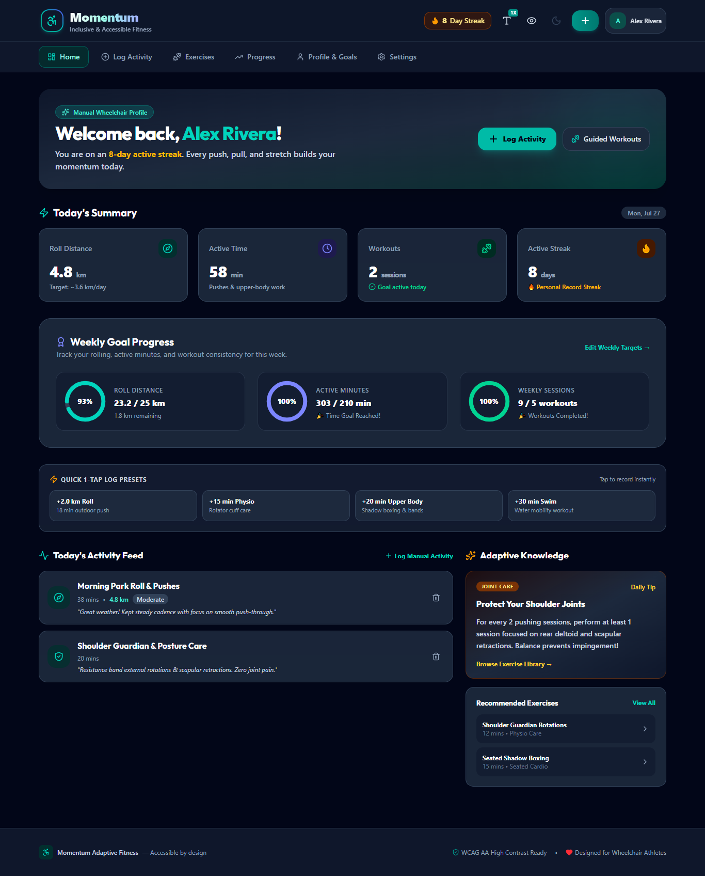
The Home screen (Dashboard).
Logging an activity
This is the main thing users do. Tapping the “+” or “Log Activity” button opens a simple form:
- First, pick the type of activity — wheeling, seated strength, physiotherapy, adaptive swimming or handcycling.
- Give it a name (for example, “Morning outdoor roll”).
- Enter the distance and how long it took. There are quick buttons (like 1.5 km, or 30 minutes) so users barely have to type.
- Choose how hard it felt and where it happened, and add a short note if you like.
- Tap “Record Activity.” The app saves it, plays a little celebration, and your dashboard updates immediately.
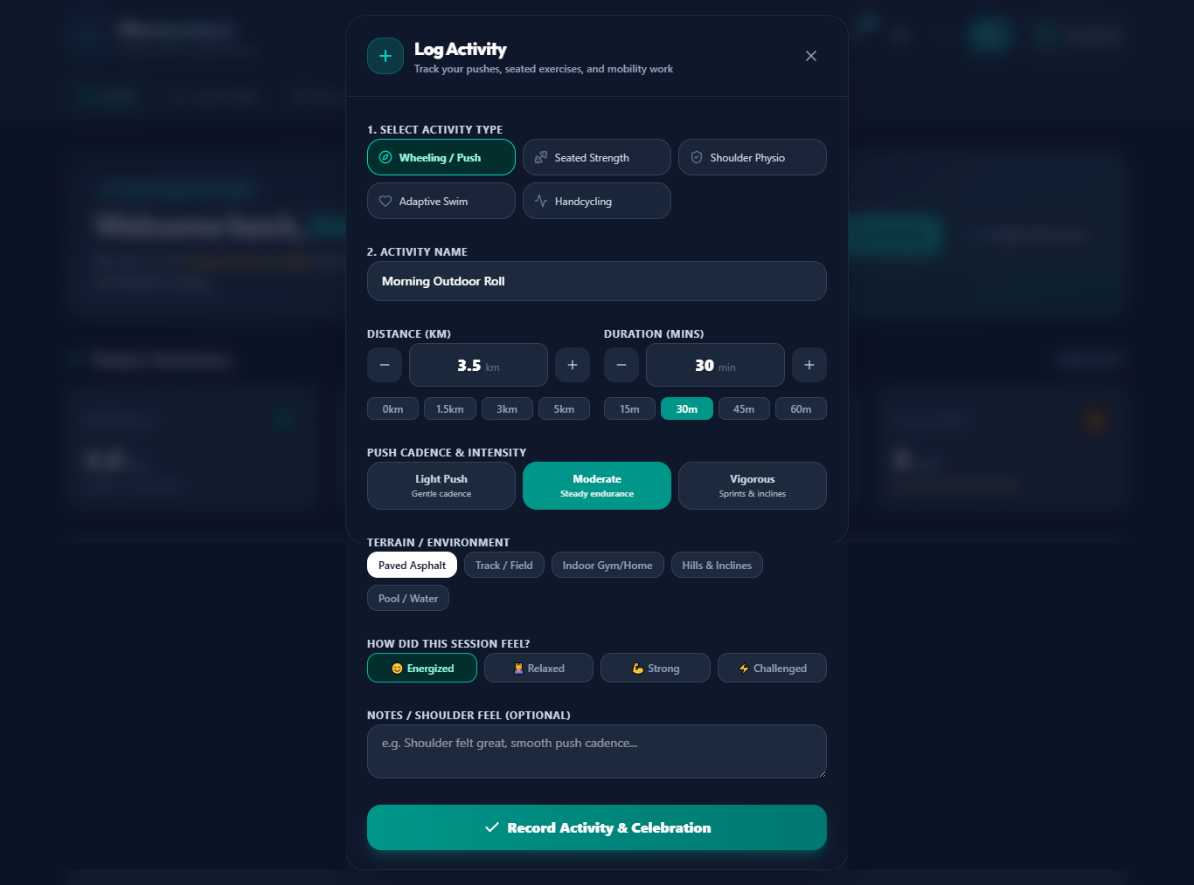
Logging an activity.
The Exercise Library
This is a set of ready-made workouts chosen specifically for wheelchair and adaptive movement — things like seated cardio, shoulder-protecting band exercises, upper-body strength and gentle stretches. Each one is shown on a card with how long it takes, which muscles it works, and what equipment (if any) you need. Users can start a guided session or quickly log that they did it.
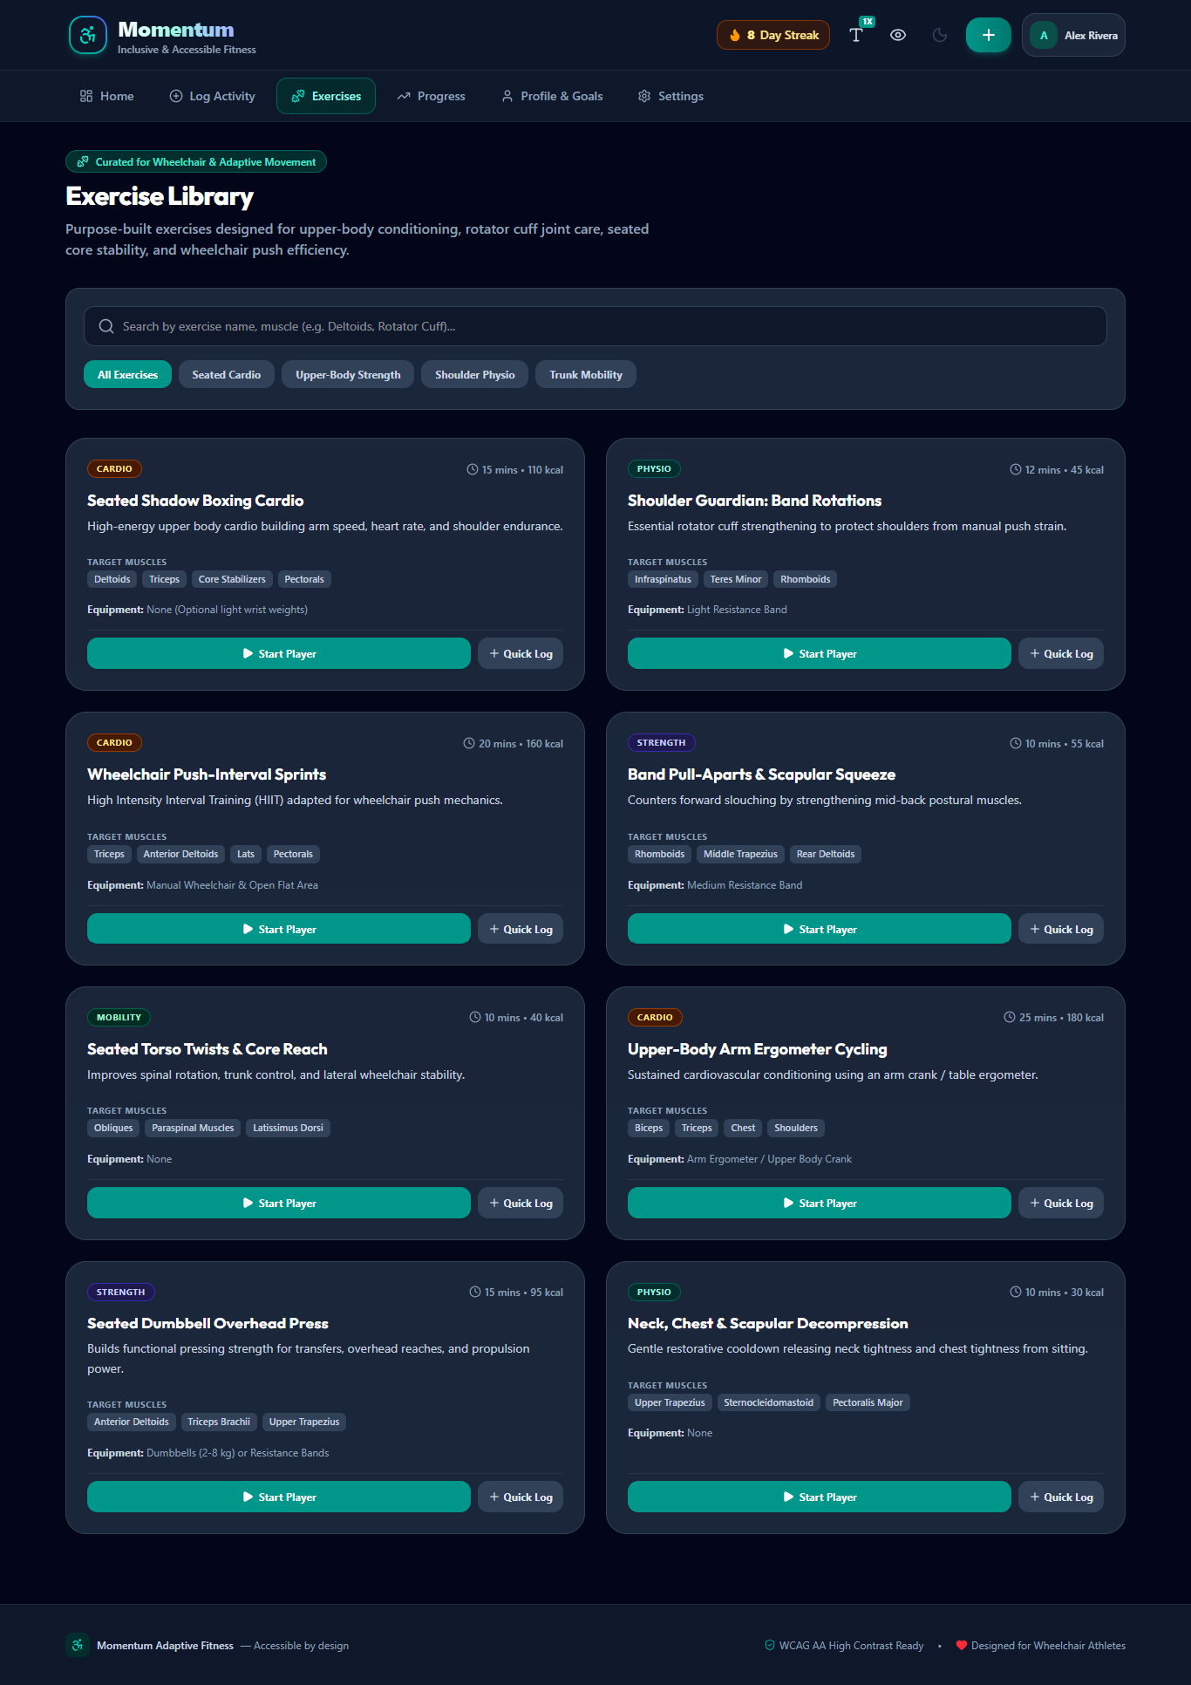
The Exercise Library.
Progress & Achievements
This screen shows how a user is doing over time. It has two charts — one for rolling distance and one for active minutes over the last two weeks — and next to each chart there is a short written summary in plain words (for example, “You averaged 24 active minutes per day”). That written summary matters: it means someone using a screen reader, who can’t see the chart, still gets the information. Below the charts is a shelf of achievement badges that unlock as the user hits milestones, which helps keep people motivated.
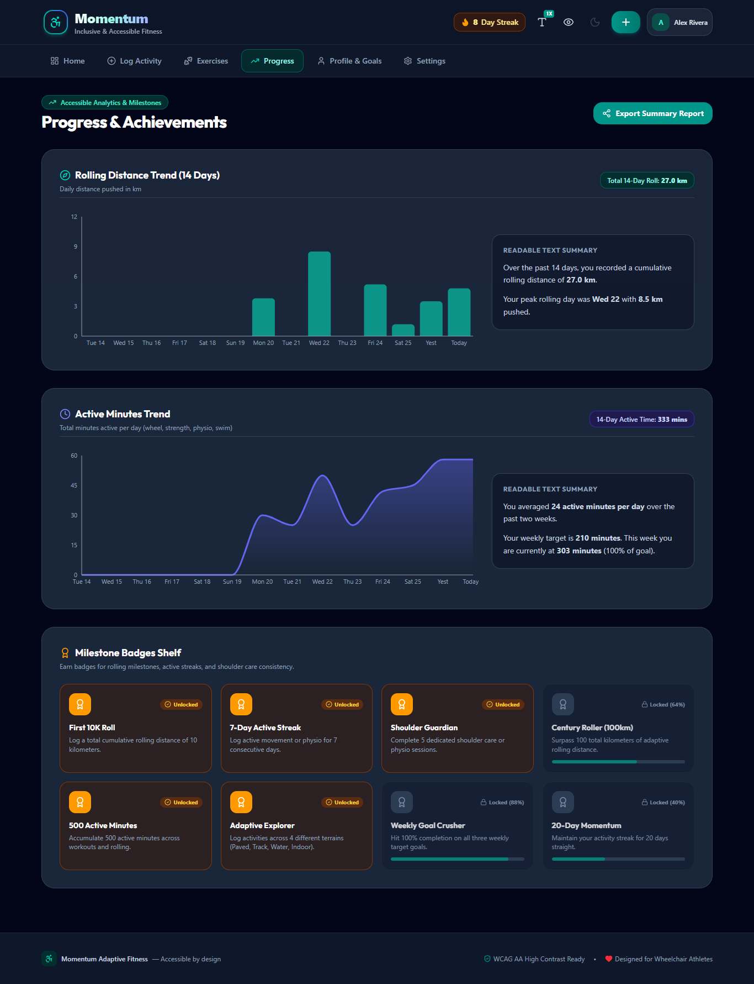
Progress & Achievements.
Profile & Goals
Here a user can update their name, their mobility profile and any notes, and adjust their weekly targets for distance, active minutes and sessions whenever their needs change.
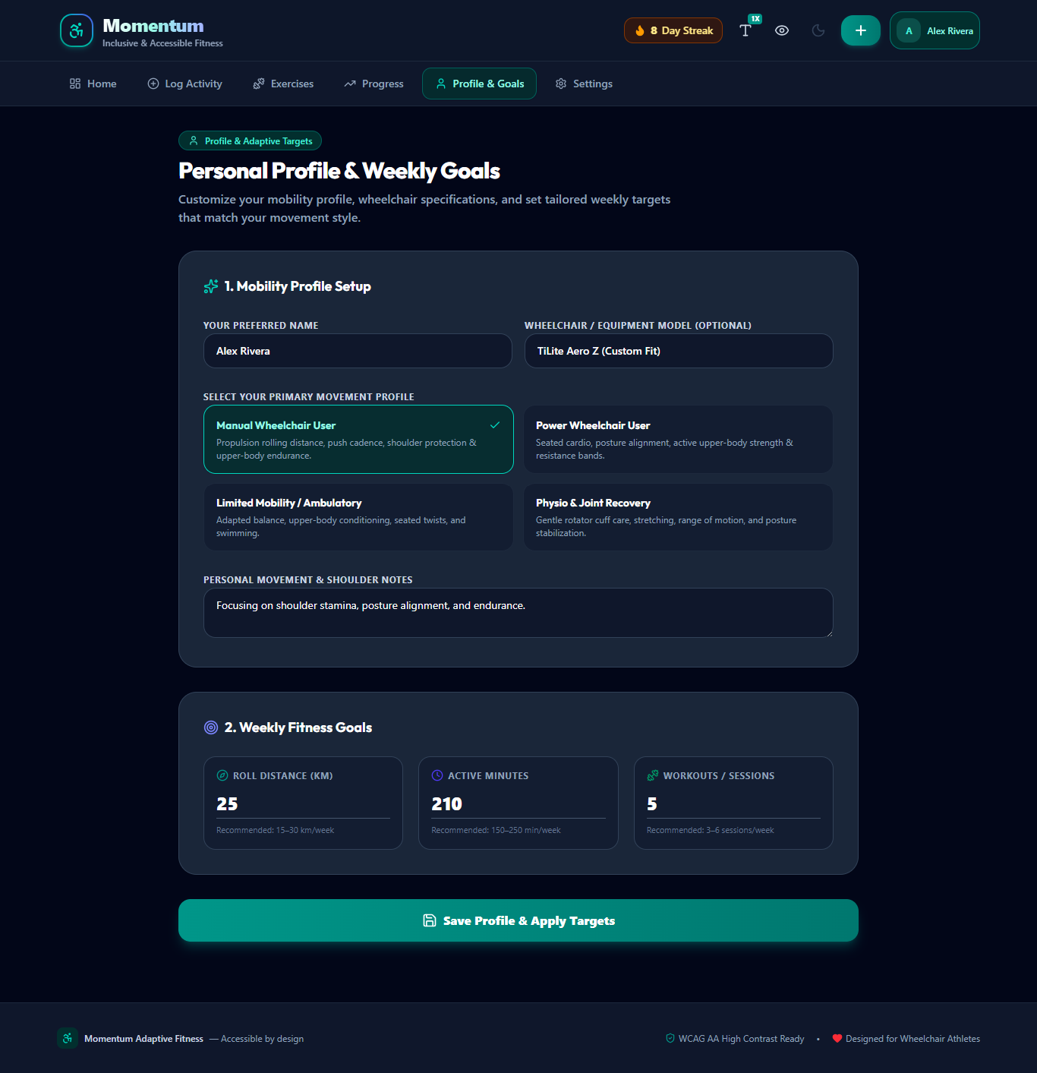
Profile & Goals.
Settings & Accessibility
This is where the app proves it was built for its users. Everything here can be changed instantly:
- Dark or light theme — for comfort in different lighting.
- High-contrast mode — makes text and edges sharper and easier to see.
- Text size — standard, large or extra large, for easier reading.
- Distance unit — kilometres or miles, and reminder settings.
- Reset app data — returns the app to its starting state.
At the defence: if an examiner asks whether an app for people with disabilities is itself accessible, open Settings and turn on high-contrast mode and the largest text size in front of them. Showing it is far stronger than saying it.
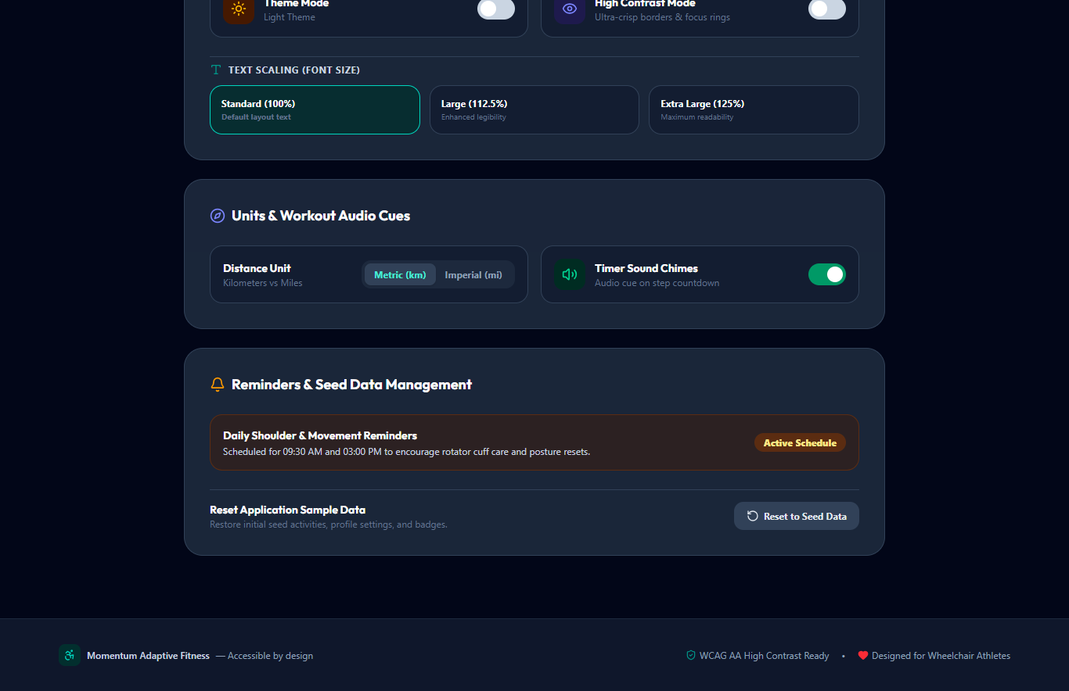
Settings & Accessibility.
The one honest point to know
Momentum records activity that the user types in — it does not read it automatically from a smartwatch or sensor. This is normal and correct for a web app, and it’s worth saying plainly: the app is an activity logger and goal tracker, not a medical measuring device. Connecting it to wearable devices in the future is mentioned in the report as the next step. Saying this yourself shows you understand your own system.
Momentum — Adaptive Fitness Tracker. Prepared for Ogbonna Emmanuel.

